# Project Methodology

## Introduction

In this project, several libraries and API will be used to integrate YARA functionality and automatic generation from within the application. The project will mostly follow the standard Software Development Life Cycle (SDLC) with a few changes to suit the project requirement.

## Methodology

Figure ‎3.2.1 Methodology Framework

The first step of this project is to study the files that are going to be analyzed, which are sample APKs. There are several components inside an APK file such as META-INF, AndroidManifest.xml, classes.dex, and resources that are required by the app. Next comes the design phase, the prototype design of the app will be created used Visio. Next, the application will be developed using Flutter Framework because of its rich library to quickly develop a functioning prototype. Then, the app will be tested by sample APKs take note of the results. Then we record and document project findings and the performance of the app in a report.

## Project Milestones

A project milestone is a scheduling method for identifying a specific stage in a project's timeline. It's a useful for determining schedule goals and ensuring the research’s success.

|  |  |  |
| --- | --- | --- |
| Process/Phases | Activities | Completion Date |
| Analysis | * Discover previous work on the application of malware investigation with YARA * Find and evaluates the tools that are going to be used | 22 April 2022 |
| Design | * Use of templates to picture the rough design of the application * Creation of design prototype | 9 May 2022 |
| Development | * Coding process of the application * Implementation of YARA tools into the application | 24 May 2022 |
| Testing | * Evaluation of the application to make sure it is functioning properly * Finding and fixing errors within the application | 28 May 2022 |
| Report | * Documentation of the development process and user guide on application usage | 6 June 2022 |

Table ‎3.3.1 Project Milestones Table

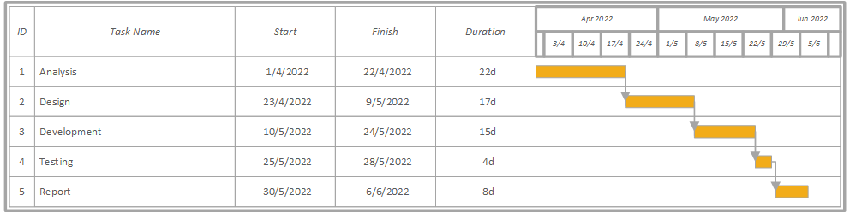

Figure ‎3.3.1 Gantt Chart

## Conclusion

This chapter specifies the development approach utilized in this project. This will follow Software Development Life Cycle for on-time and smoother development. Prototype will also be developed to identify if the software functionalities are working as intended. This chapter also included a timetable for the project. The analysis and design of this project will be discussed in the next chapter.